# Workshop: Areas, Cache and Testing

Workshop for the ["ASP.NET Advanced" course @ SoftUni](https://softuni.bg/trainings/4369/asp-net-advanced-february-2024)

The "House Renting System" **ASP.NET Core MVC App** is a Web application for **house renting**. Users can look at **all** **houses** with their **details**, **rent a house** and look at **their rented houses**. They can also **become** Agents. Agents can **add houses**, see their **details** and **edit** and **delete** only **houses they added**. The Admin has **all privileges** of Users and Agents and can see **all registrations** in the app and **all made rents**.

## Introduce Admin Area

In this task we will **create an admin area**. The area will group the app **functionalities**, which are **accessible only to** **the** Admin, in a **separate MVC structure**. Classes from the area will have **different namespaces** from the main MVC structure and their methods will be **invoked on different URLs**. Let's see how to do this.

First, create an "Admin" **folder** in the "Areas" **folder** in the "HouseRentingSystem.Web" **project**. Also, it is a good idea to **move the** AdminConstants **class** to this folder, as this is the admin's space in the class structure. The **class** should have a **changed namespace**. It should look like this:

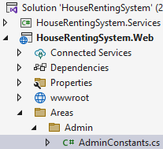 🡪 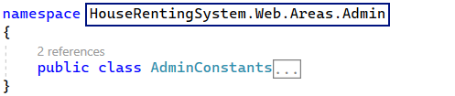

**Create** "Controllers", "Models" and "Views" **folders** in the "Admin" **folder**. They will hold **area's** **MVC classes**:

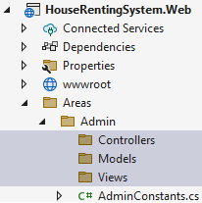

Now let's **create a base controller class** for the **controllers of the admin area**. The AdminController should be **accessed only by the** Admin (in its role) and should **set the area name for all child controller classes**.

The **area name** is defined in the AdminConstants **class**:

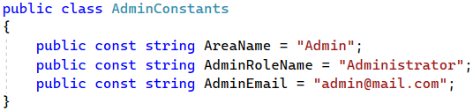

The AdminController should **inherit the base** Controller **class** and look like this:

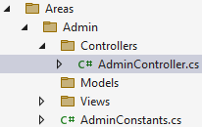 🡪 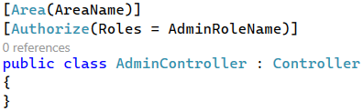

Before we create the controllers, let's pay attention to the "Views" **folder**. In it, we should have the "_ViewImports.cshtml" and "_ViewStart.cshtml" **partial views** to render the area views properly. **Copy the files** from the main "Views" **folder** and **leave them** as they are for now. We will **change and clear them** later, if needed:

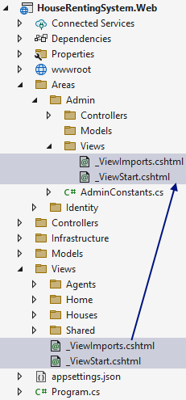

The final step before we start implementing **admin area** pages is to **add a new route in** "**Program.cs**" file:

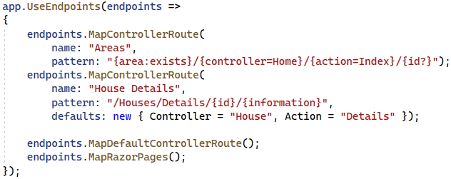

The **controller route** we have added will form **URLs** like "/Admin/" for the "Home" **page** and "/Admin/Users/All" for **accessing a page with all users**, which is accessed only by the Admin.

### Step 1: Create Admin Pages

#### "Home" Page

The "Home" **page** of the **admin area** is **accessed on** "/Admin/" and should look like this:

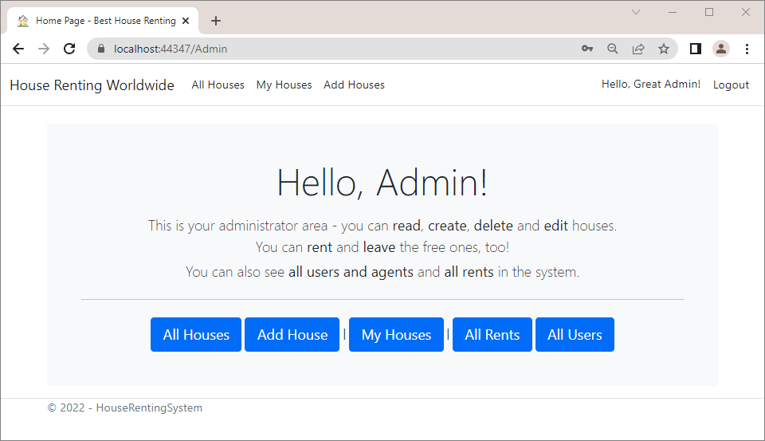

To create the "Home" **page**, **create a** HomeController **class**, which should **inherit the** AdminController **base** **class**. Note that **controller names of areas** may be the same as those from the main MVC structure of the app. It does not matter, as they are **accessed depending on the area name**.

The new HomeController should have an Index() **method**, which **returns a view**:

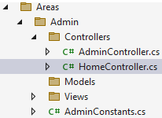 🡪 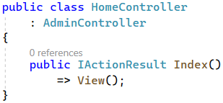

Now **create the** "Index.cshtml" **view** for the above **controller action** in the "/Areas/Admin/Views/Home" **folder**. It should look like this:

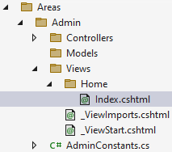 🡪

|  |
| --- |
| @{  ViewData["Title"] = "Home Page";  }  <div class="mt-4 p-5 bg-light text-center">  <h2 class="display-4">Hello, Admin!</h2>  <p class="lead mb-1 mt-3">  This is your administrator area - you can <b>read</b>, <b>create</b>,  <b>delete</b> and <b>edit</b> houses.  <br />You can <b>rent</b> and <b>leave</b> the free ones, too!  </p>  <p class="lead mt-1">  You can also see <b>all users and agents</b> and <b>all rents</b> in the system.  </p>  <hr class="my-4">  <**a** **asp-area**="" **asp-controller**="House" **asp-action**="All"  class="btn btn-primary btn-lg">All Houses</**a**>  <**a** **asp-area**="" **asp-controller**="House" **asp-action**="Add"  class="btn btn-primary btn-lg">Add House</**a**>  <span> | </span>  <**a** **asp-area**="Admin" **asp-controller**="House" **asp-action**="Mine"  class="btn btn-primary btn-lg">My Houses</**a**>  <span> | </span>  <**a** **asp-area**="Admin" **asp-controller**="Rent" **asp-action**="All"  class="btn btn-primary btn-lg">All Rents</**a**>  <**a** **asp-area**="Admin" **asp-controller**="User" **asp-action**="All"  class="btn btn-primary btn-lg">All Users</**a**>  </div> |

Now, if you **run the app** and **log in with the** Admin, you will see the "Home" **page for all users**, as **all users are redirected to it** after login.

To change that and display the **admin** "Home" **page**, go to the Index() **method** of the HomeController in the "HouseRentingSystem.Web" **project**. The method should **redirect to** "/Admin/" when the **current** **user is the** Admin:

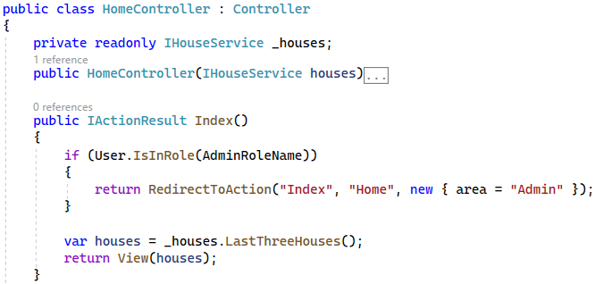

Now **run the app** and make sure that the **correct page is displayed** when you **log in with the** Admin. However, when you **click on the "**Home**" page buttons**, most of them **do not open existing pages** yet. Let's continue with implementing the rest of the pages to fix this problem.

#### "My Houses" Page

The "My Houses" **page** of the Admin will show the **houses they created** and the **houses they rented**. The page is shown on the picture below:

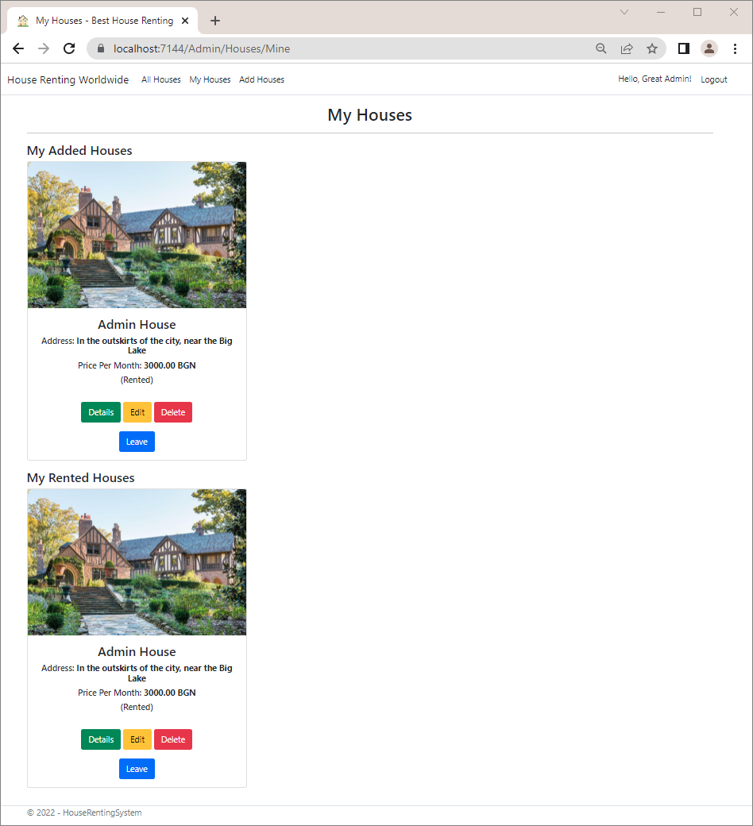

To **implement the above page**, first **create a model** in the "/Areas/Admin/Models" **folder**, which should have the **added and the rented houses by the admin**, as a **collection of type** HouseServiceModel. It should be the following:

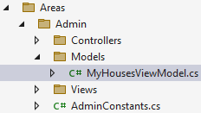 🡪

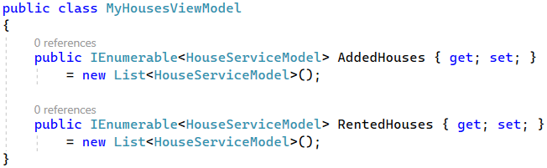

Then, **create a** HouseController in the Admin **area** with a Mine() **method**. **Inject services** in the controller and use them to **pass the above model to a view**:

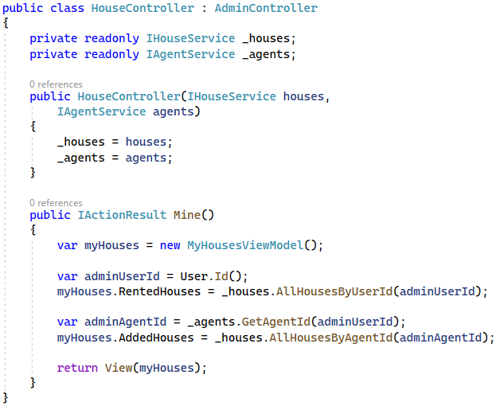

Create the "Mine.cshtml" **view** in the "/Admin/Views/Houses" **folder**, which should **accept a** MyHousesViewModel and **pass each house to the** "_HousePartial.cshtml" **partial view**. Note that we should use the Html.PartialAsync() **HTML helper method**, as the **partial view is from another project**. The view should look like this:

|  |
| --- |
| @model MyHousesViewModel  @{  ViewBag.Title = "My Houses";  }  <h2 class="text-center">@ViewBag.Title</h2>  <hr />  <h4>My Added Houses</h4>  @if (!Model.AddedHouses.Any())  {  <h2 class="text-center">You have no added houses yet!</h2>  }  <div class="row">  @foreach (var house in Model.AddedHouses)  {  @await Html.PartialAsync("~/Views/House/_HousePartial.cshtml", house)  }  </div>  <h4>My Rented Houses</h4>  @if (!Model.RentedHouses.Any())  {  <h2 class="text-center">You have no rented houses yet!</h2>  }  <div class="row">  @foreach (var house in Model.RentedHouses)  {  @await Html.PartialAsync("~/Views/House/_HousePartial.cshtml", house)  }  </div> |

Don't forget that you should **add the** MyHousesViewModel **class namespace** to the "_ViewImports.cshtml" **file** to use the model.

**Run the app** and make sure that the "My Houses" **page** is displayed correctly on the "/Admin/House/Mine" **URL**.

Try to **click on the** [Details] or any other **button under a house**. You should see that they **return an error**. The reason for this is that they **form an URL with the current area name** but our methods for these functionalitites are **not part of the admin area**.

Because of this problem we should **modify the** <a> **tags of buttons** **in view**s. They should have the asp-area **tag** **helper**, so that they **redirect to the correct controller actions**. **Add tag helpers** to the "_HousePartial.cshtml" **partial view** to **specify the area** (which is the default one without a name) like this:

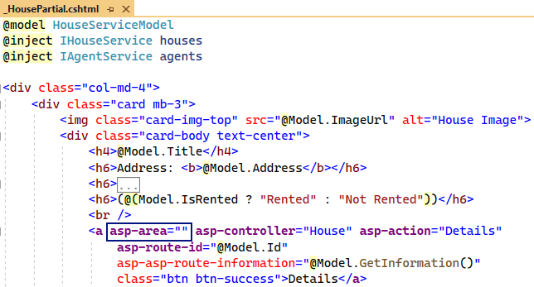

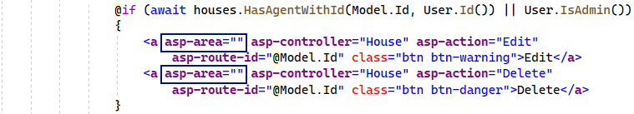

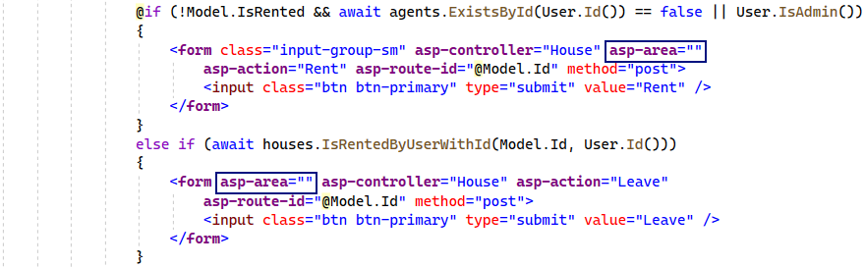

Now **all buttons redirect to the correct pages**, which are in the **default area**. However, the "My Houses" **link** in the **navigation bar** will always point to "/House/Mine" and **not** "/Admin/House/Mine", independently of the user. For this reason, we should go to the common HouseController and **modify the** Mine() **method** **to redirect to the admin area** if the **current user is the** Admin. Do it like this:

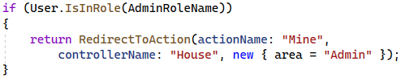

**Run the app** again and **log in with a user**, who is **not the** Admin. You should be **redirected to the** "My Houses" **page** when you **click on its link in the navigation bar**:

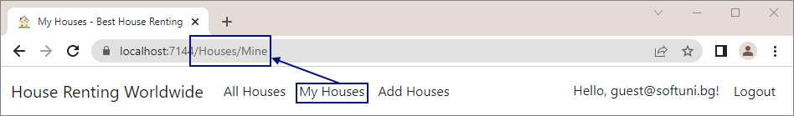

Now **log in with the** Admin. The **navigation link** should access the "My Houses" **page** on "/Admin/Houses/Mine":

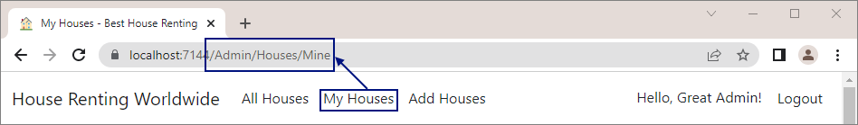

#### "All Users" Page

The "All Users" **page** should be **visible only to the** Admin and **display all app users and if they are agents or not**. It should be **accessible on** "/Users/All":

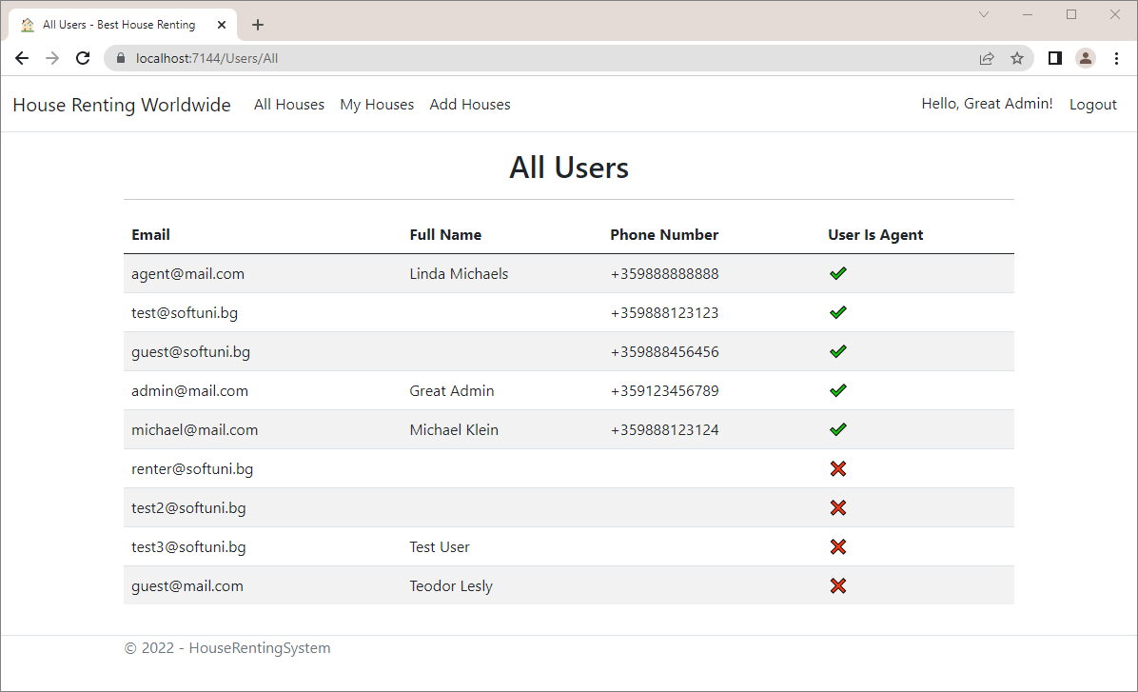

In the current case we will need a **service method to return all users** from the database. **Define an** All() **method** in the IUserService **interface** from the "HouseRentingSystem.Core" **project**:

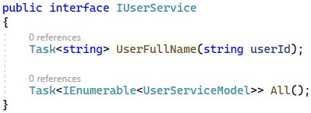

Note that the above **method** returns a **collection of type** UserServiceModel, which is part of the "/User/Models" **folder**, and has the following **properties**:

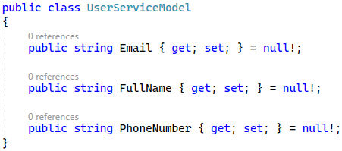

The UserService **class** should **implement the above** All() **method**. Do not forget that you need to **inject** AutoMapper before that. Write the class like this:

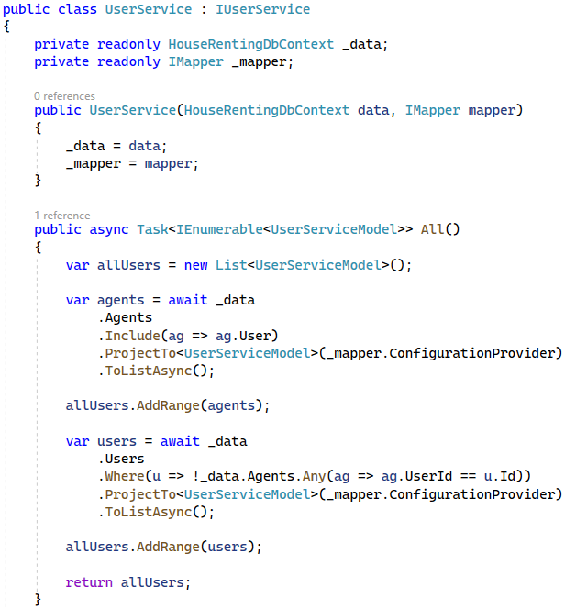

Be **careful with the mappings**. They should be **added to the** ServiceMappingProfile **class**. Note that **users don't have** **phone numbers** and, in this case, the PhoneNumber **model property should contain an empty string**. The **mappings** should be the following:

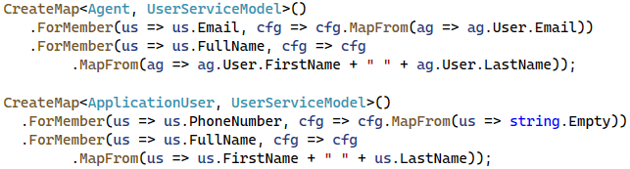

Next, create a UserController in the **admin area with an** All() **method**, which should **use the service method** we just created and **return a view**. Don't forget to set the **controller action route** to "/User/All":

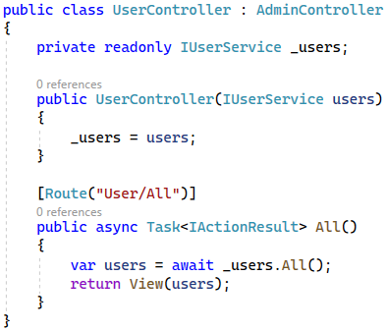

Finally, **create an** All.cshtml **view** in the "/Admin/Views/User" **folder**. You can copy the code from here:

|  |
| --- |
| @model IEnumerable<UserServiceModel>  @{  ViewBag.Title = "All Users";  }  <h2 class="text-center">@ViewBag.Title</h2>  <hr />  <table class="table table-striped">  <thead>  <tr>  <th><label>Email</label></th>  <th><label>Full Name</label></th>  <th><label>Phone Number</label></th>  <th><label>User Is Agent</label></th>  </tr>  </thead>  <tbody>  @foreach (var user in Model)  {  <tr>  <td><label>@user.Email</label></td>  <td><label>@user.FullName</label></td>  <td><label>@user.PhoneNumber</label></td>  <td>  @if (user.PhoneNumber != string.Empty)  {  <label>✔</label>  }  else  {  <label class="text-center">❌</label>  }  </td>  </tr>  }  </tbody>  </table> |

#### "All Rents" Page

The "All Rents" **page** will **display rented houses** with **information about the house** **agent and renter**. It should be **accessed on** "/Rent/All" by the Admin and look like this:

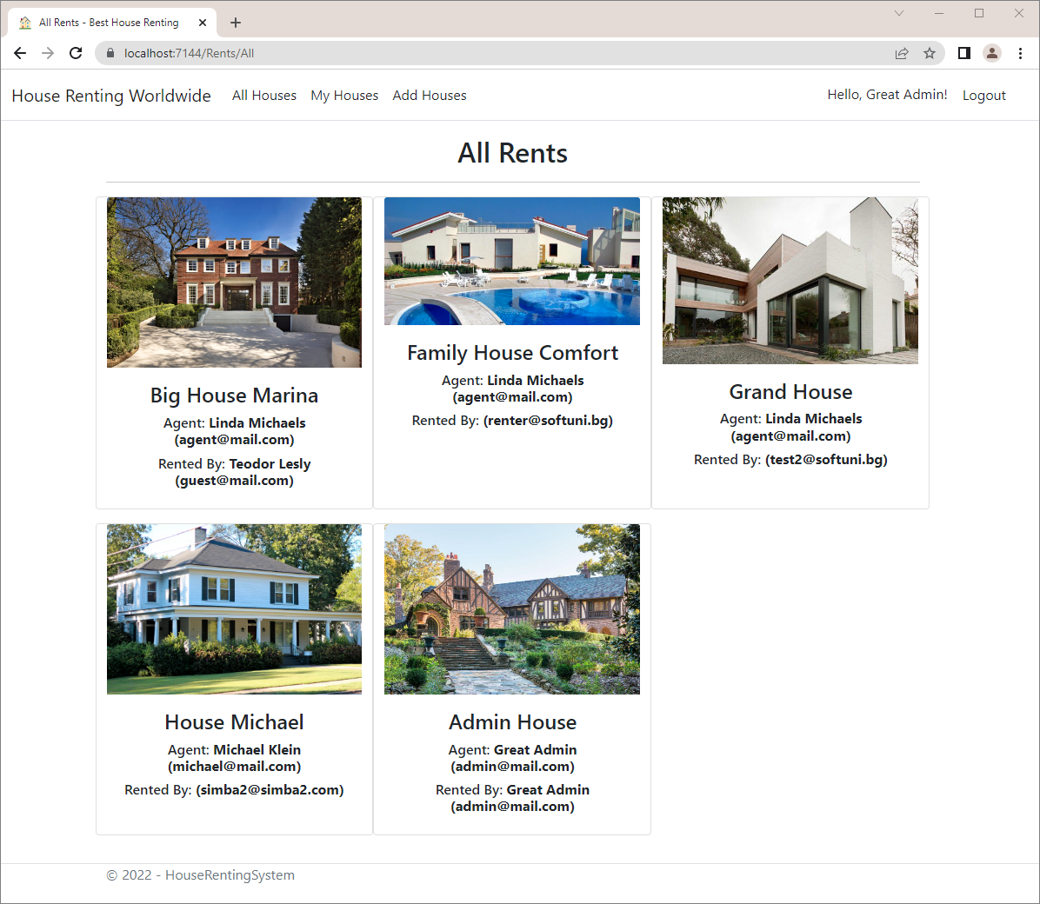

To implement the above page, we will need to **access the house renter data**. For this reason, we will first **add a** Renter **property** to the House **entity** in the "Data" **folder** of the "HouseRentingSystem.Data" **project**. It should be of **type** **Application**User:



Then, let's **create a service with a service model to return all rents**. Go to the "HouseRentingSystem.Core" **project** and **add a new folder** "Rent" to the "**Contracts**", "**Services**" and "**Models**" folders. **Create a** IRentService **interface** with an All() **method**, which should be **implemented in a** RentService **class**. The method will **return a collection of type** RentServiceModel. All classes are shown below:

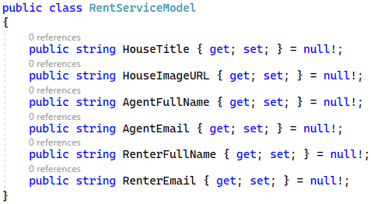

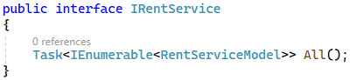

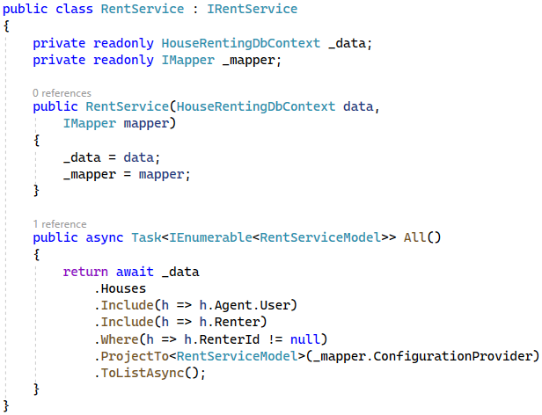

Note that we should **include the agent user** and the **renter of the house** when we **extract data from the database**, so that we **use them for mapping**.

Before we continue, don't forget to **register the service in Program class** of the "HouseRentingSystem.Web" **project**:



Go back to the "HouseRentingSystem.Services" **project** and **add the mapping from** House **to** RentServiceModel to the ServiceMappingProfile **class**. Note that you should **map all properties**, as their **names don't match**:

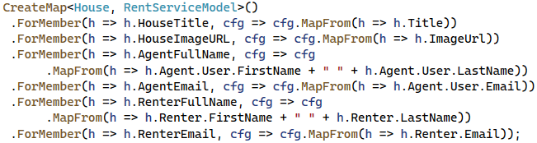

Next, in the web project, **add a** RentController **class** with an All() **method**, which **uses the above service method** and **returns a view**:

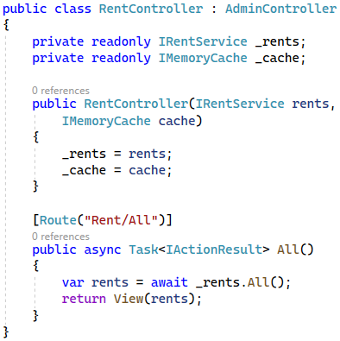

Finally, add the RentServiceModel **namespace** to the "_ViewImprots.cshtml" **file** and **create a folder** "Rent" in the "/Admin/Views" **folder**, which will have an All.cshtml **file**. It should be the following:

|  |
| --- |
| @model IEnumerable<RentServiceModel>  @{  ViewBag.Title = "All Rents";  }  <h2 class="text-center">@ViewBag.Title</h2>  <hr />  <div class="row">  @foreach (var rent in Model)  {  <div class="card mb-3 col-4">  <img class="card-img-top" src="@rent.HouseImageURL" alt="House Image">  <div class="card-body text-center">  <h4>@rent.HouseTitle</h4>  <h6>Agent: <b>@rent.AgentFullName (@rent.AgentEmail)</b></h6>  <h6>Rented By: <b>@rent.RenterFullName (@rent.RenterEmail)</b></h6>  </div>  </div>  }  </div> |

**Run the app**, **navigate to the** "All Rents" **page** on "/Rent/All" and make sure that **rents are displayed** **correctly**.

In addition, it is a good idea to **clear the** _ViewImports.cshtml **file** in "/Areas/Admin/Views" **from unused** **namespaces**.

### Step 2: Modify Layout

In this task, we want to **modify our navigation bar links**. When the **user is not the** Admin, their links should be the following (they are **not changed**):

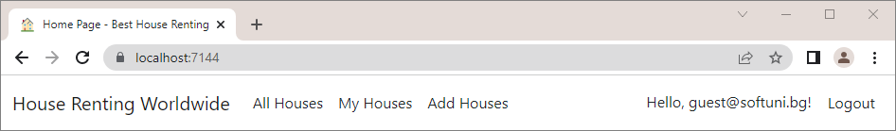

However, when the Agent **is logged-in**, their **navigation bar should have additional links** in a **dropdown menu**:

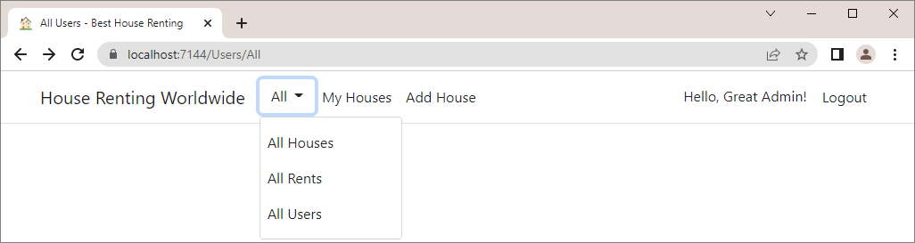

To do this, we will create a **special layout view** for the **admin pages**. **Copy the "**_Layout.cshtml**"** **view** and **rename** it to "_AdminLayout.cshtml". **Move it to** **a** "/Areas/Admin/Views/Shared" **folder**.

**Modify** the _AdminLayout.cshtml **view** by **adding a dropdown with links** like this:

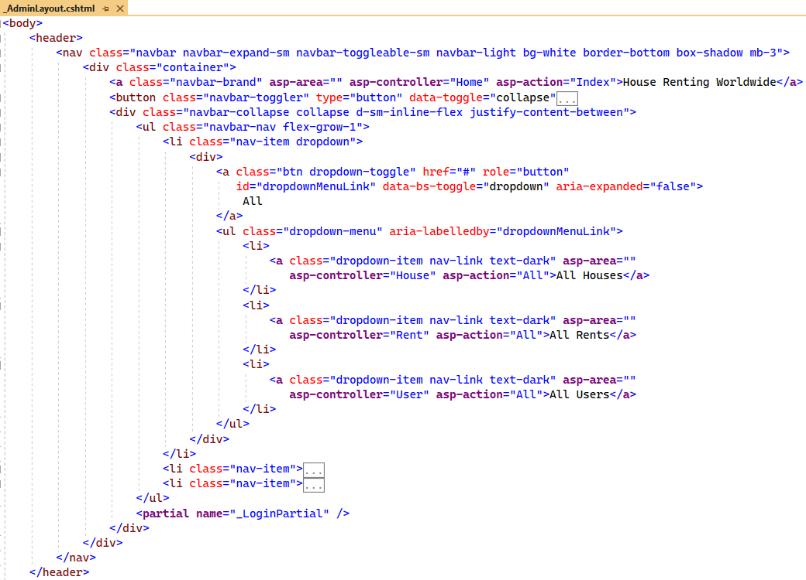

Now go to the "_ViewStart.cshtml" **file** in the "/Admin/Views" **folder** and **set the layout** with the new file:

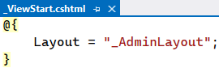

Now we should **modify the "**_ViewStart.cshtml" **file** in the main "Views" **folder**, as the "All Houses" **page** uses it. Do it as shown below, so that the **layout is changed**, **depending on the user**:

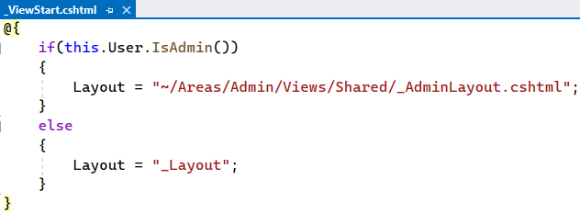

Run the app and **look at the navigation bar** when you **log in with the** Admin and **with another user**. Links should **redirect you to the correct pages**.

## Cache Pages

In this task, we want to **cache our** "All Users" **and** "All Rents" **pages**, as this will improve the overall **app's performance**. We will use **cache** **stored in the memory**, which is the simplest cache. The IMemoryCache **interface** will allow us to **refresh a given** **page on a set amount of time**, no matter if there is a **new data to be extracted from the database**.

To do this, we should first **register the cache service** in **Program class** of the "HouseRentingSystem.Web" **project**:



Be careful where you **place the registered cache service** between other services.

Next, go to the AdminConstants **class** and **add cache keys for the two pages**. We need them, as they are **unique** **identifiers for each object** **in the cache**. Do it like this:

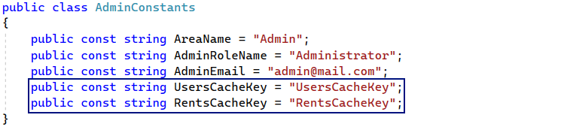

### Step 1: Cache the "All Users" Page

Now we will cache the "All Users" **page** first. To do this, go to the UserController **class** in the "/Areas/Admin/Controllers" **folder** and **inject the cache service**:

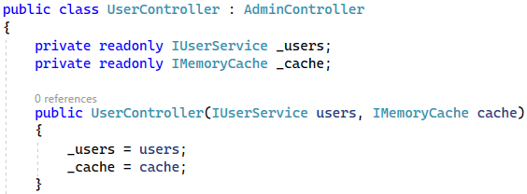

Then, in the All() **method**, let's first check whether a **cache with the cache key and the users** **is already created**:

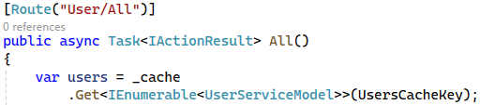

Then, if the **cache is not created or empty**, **create a cache with the cache key**, **users** and **an expiration of 5 minutes**:

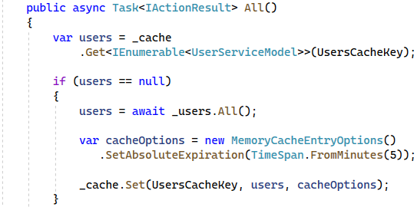

At the end, **return a view** with the **users**:

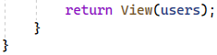

Now **run the app** in the browser, **log in with the** Admin and **navigate to the** "All Users" **page**:



Then, **register a new user**:

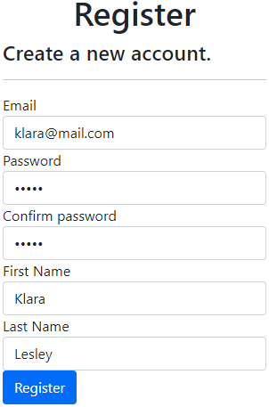

After a **successful registration**, **log in** with the Admin **again** and **look at the** "All Users" **page** – it should **not have** **the newly-created user** yet. Note that the **users cache** **is saved in the server's memory**, so you should **not rebuild or** **refresh** **the** **app**!

**Wait for 5 minutes** after the registration and **refresh the** "All Users" **page**. Then it should **display the new user**.

### Step 2: Clear the Cache when Creating a New User

Now our "All Users" **page** is **refreshed on every 5 minutes**, no matter if there is a **new user in the database or not**. However, this is **not appropriate**, as the Admin **should not wait** to see new users. For this reason, we need to **clear the cache** when a **new user is created** successfully.

To do this, go to the Register.cshtml.cs **class** in the "/Areas/Identity/Pages/Account" **folder** and **inject** **the memory cache interface** through the **constructor**:

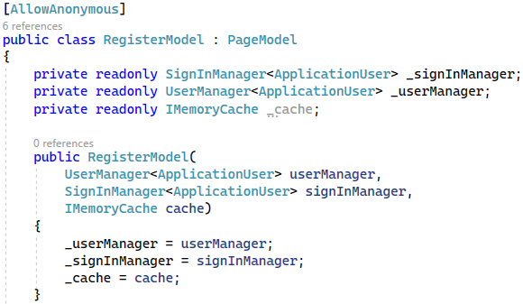

Then, **clear the cache** when the **user is created successfully** in the OnPostAsync(…) **method**:

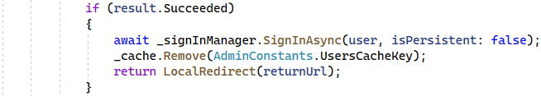

Now **test the new modification**. Go to the "All Users" **page** with the Admin and look at it:

**Register a new user** and make sure that they are **displayed immediately** on the "All Users" **page**:

Now the **caching** of the users' page is **done correctly**.

### Step 3: Cache the "All Rents" Page

Now let's **cache the** "All Rents" **page** in the same way. Go to the RentController and **inject the service**. Then, **create a cache with a 5-minute expiration** and the **rents**. Do it like this:

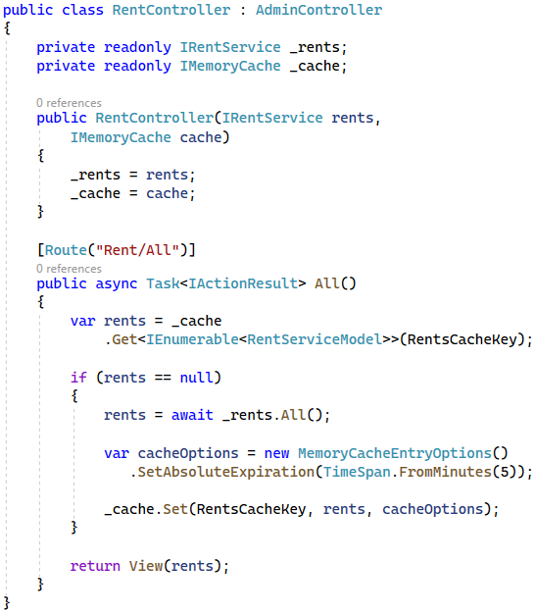

**Run the app** and **navigate to the** "All Rents" **page** with the Admin. You should see **all rented houses**:

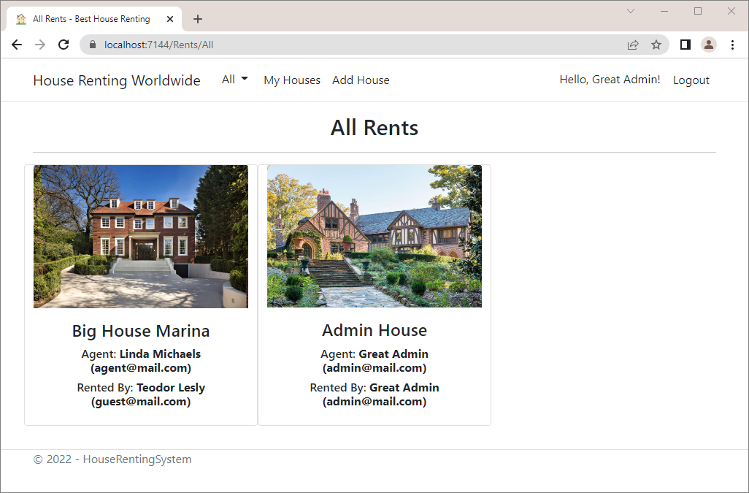

**Rent a house** of your choice, for example the "Michael" **house**. It should be **displayed on the** "My Houses" **page**, but **not on the** "All Rents" **page** yet:

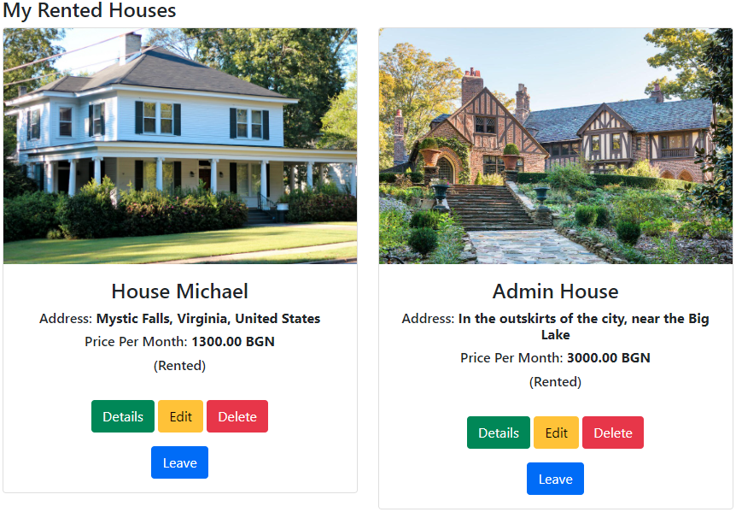

**Wait for 5 minutes** and make sure that the **rented house is displayed on the** "All Rents" **page** after **refresh**:

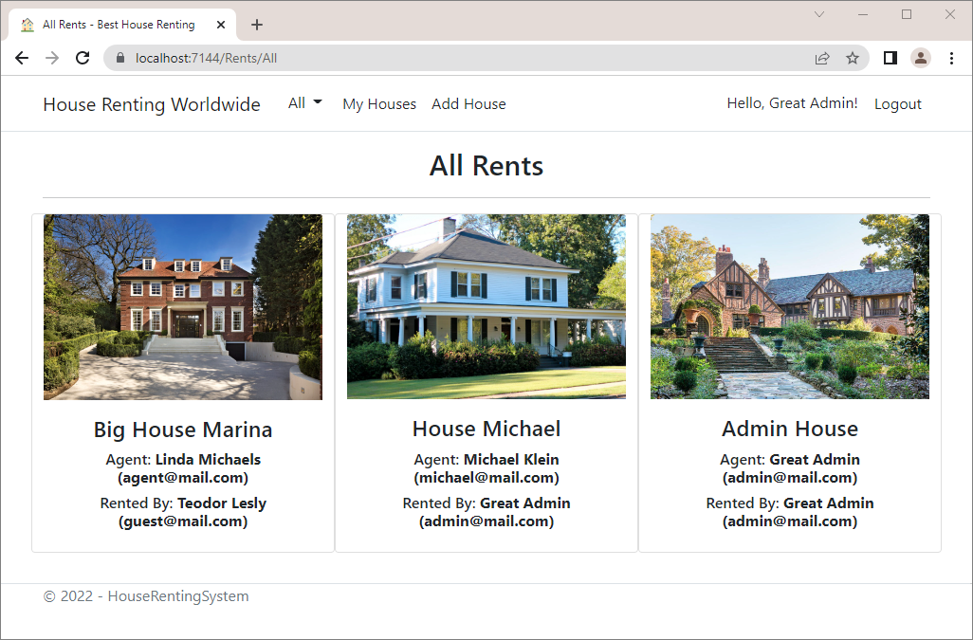

Now we have **cached pages in our app**, which are **refreshed on every 5 minutes**. However, let's again clear the cache when a house is rented or left, so that the page always displays the correct houses.

Go to the HouseController in the "/Controllers" **folder** and **inject the memory cache** through the **constructor**. Then, **clear the cache** in the Rent() and Leave() **methods**, when a **house is rented or left** successfully. Do it as shown below:

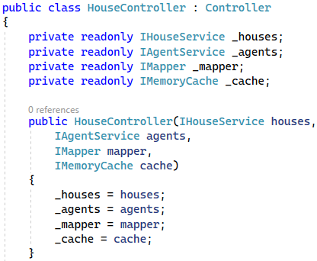

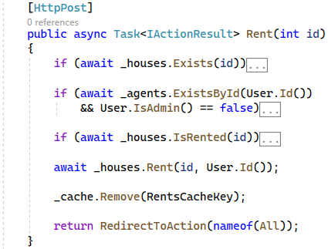

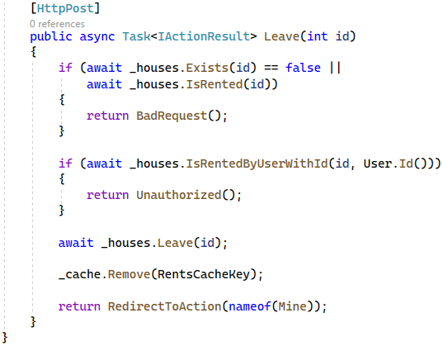

Now try to **rent or leave a house** and make sure that this action result is **displayed** on the "All Rents" **page** without any delay.

## Add TempData

TempData is used to **transfer data from view to controller** or **controller to view**. In this task, we want to **use a cookie-based** TempData to **show messages to the user** after **successful adding**, **editing**, **deleting**, **renting** and **leaving** **a house** and for **becoming an agent**. For example, the message for **successful adding of a new** **house** looks like this:



Note that these messages are shown only **once on a particular page** and **disappear when the page is refreshed**.

To **show these messages**, we will have to **add a message to** TempData in the **controllers** and **display these** **messages in views**. To display these messages on **any page** that we are redirected to (**only once**, as this is how TempData works), we will **add an alert** to the "_AdminLayout.cshtml" and "_Layout.cshtml" **views** **before** @RenderBody() like this:

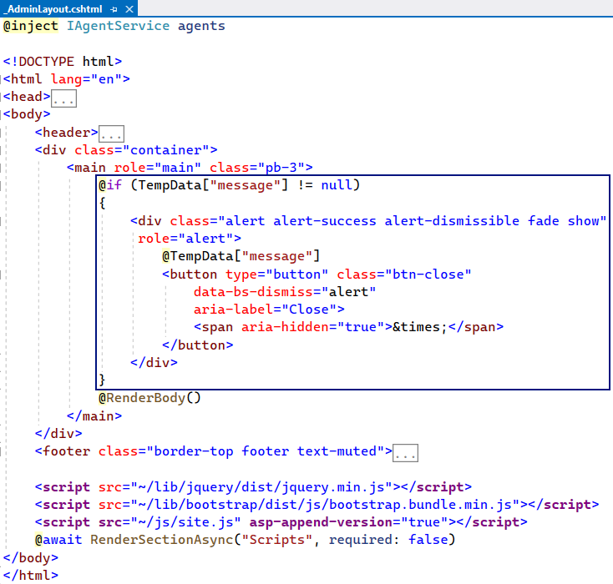

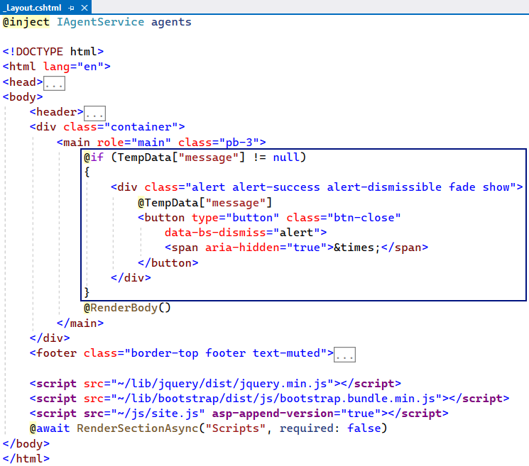

The above **code in the views** **displays** the TempData **message** (if it **exists**) in an **alert**. Now let's **add the messages** themselves.

### Step 1: Message for Becoming an Agent

Start with **adding a** TempData **message** to be shown when the **user becomes an agent**. It should be the following:



To do this, go to the AgentController in the "HouseRentingSystem.Web" **project**. In the Become(BecomeAgentFormModel model) we should **add a message**, which will be **displayed in the view**. **Set the** **message** just **before you return an action result**:

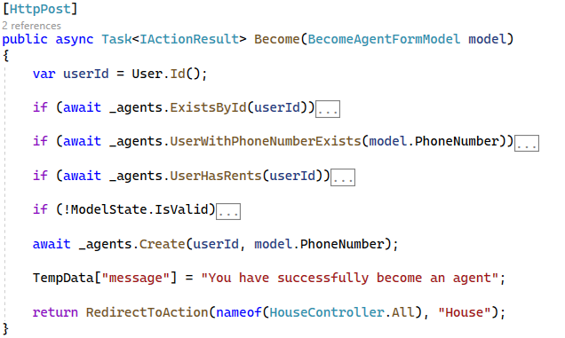

As you know, the **user is redirected to the** "All Houses" **page** after **successfully becoming an agent**. **Run the app** and **make the new user we created** (*Klara* *Lesley*) **become an agent**. When done, the "All Houses" **page** should **display the message** we added:

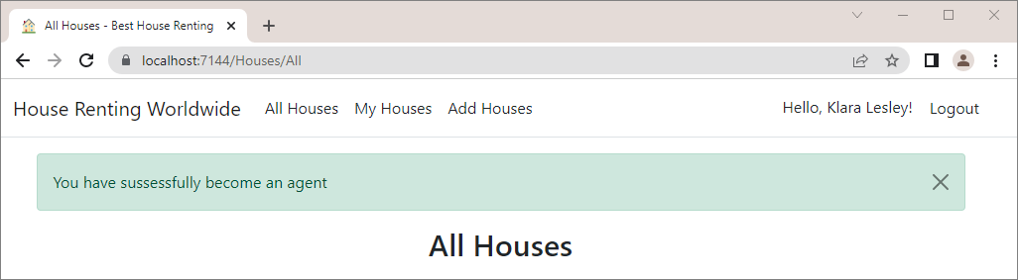

If you **refresh the page**, you will see that the **alert disappears**, as the TempData **value** is already **read and empty**.

### Step 2: Message for Adding a House

When an **agent adds a house successfully**, they should see the following message:



Go to the Add(HouseFormModel model) **method** of the HouseController and **assign a value to** TempData like this:

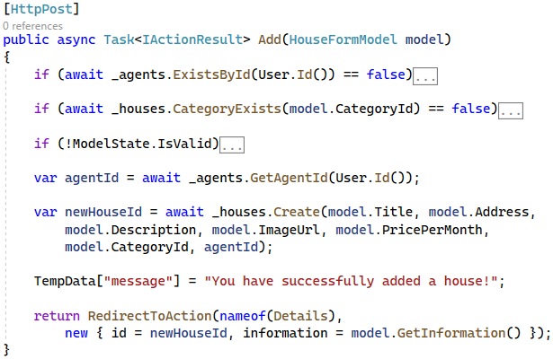

**Run the app** and **create a new house**. When the **creation is successful**, the following **alert with the message** should be shown on the "House Details" **page**:

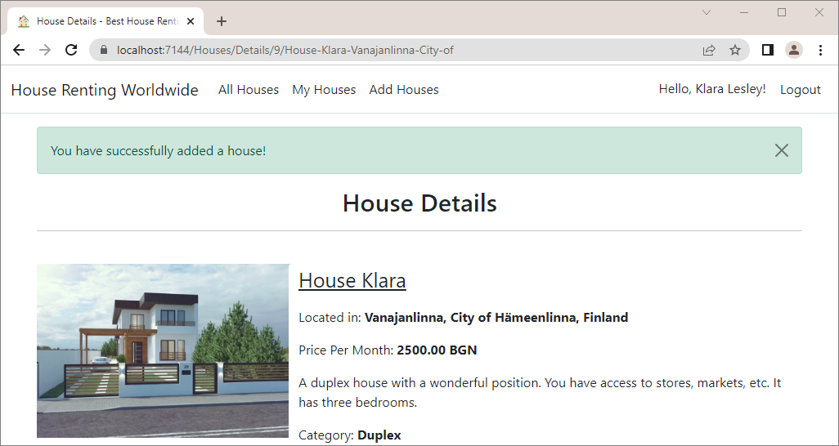

### Step 3: Message for Editing a House

The next **message with** TempData we will show is on **successfully editing a house**:



Add the TempData **message** in the Edit(int id, HouseFormModel model) **method** of the HousesController:



**Run the browser**, **edit a house** and make sure the **message is displayed correctly** on the "House Details" **page**:

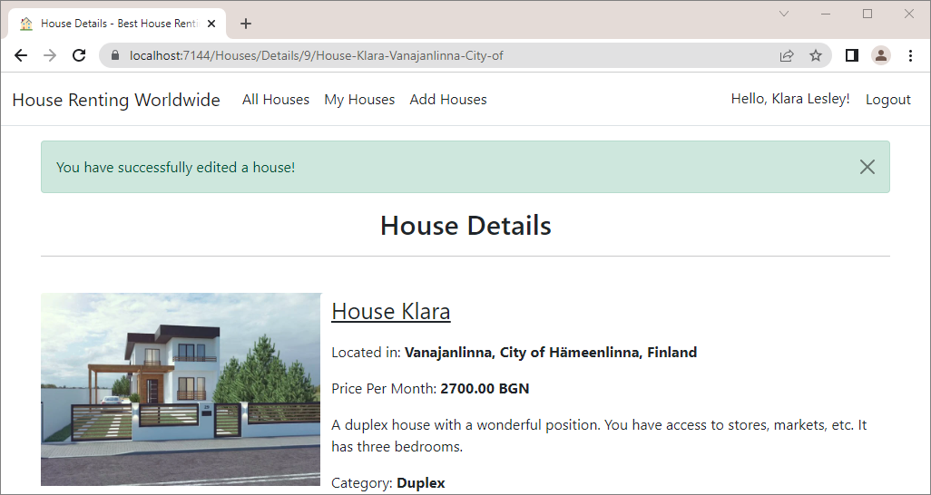

### Step 4: Message for Deleting a House

The **message for** **successfully deleting a house** is the following:



**Assign a value** to TempData in the Delete(HouseDetailsViewModel model) **method** of the HouseController:



**Delete a house** and make sure the **message is displayed** on the"All Houses" **page**:

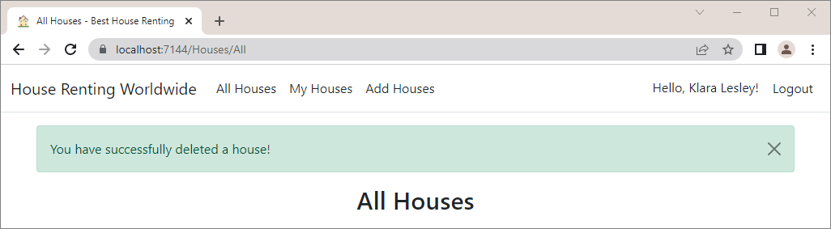

### Step 5: Message for Renting a House

The next message we will show is when a **user rents a house**:



Write the following code to the Rent(int id) **method** in the HouseController **class**:



**Rent a house** and see if the **message is displayed correctly** on the "My Houses" **page after the redirect**:

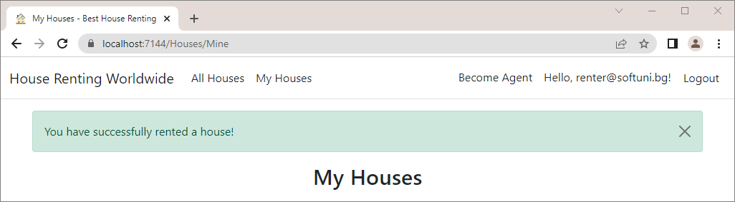

### Step 6: Message for Leaving a House

The last message we should display is when a **user leaves a rented house**. It should look like this:



Assign a TempData **value** in the Leave(int id) **method** of the HouseController:



Try to **leave a house** and make sure the **message is displayed** on the "My Houses" **page** like this:

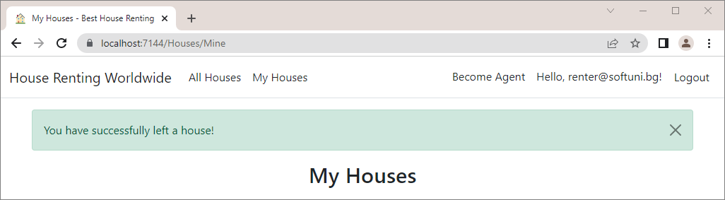

Now we have **added success messages** for user actions with TempData and improved our app design to be more **user-friendly**.

## Write Unit Tests

Those were the **last steps for developing** **our** "HouseRentingSystem" **app**. Now, we will see how to **write** **tests** for the app's functionalities we already implemented.

### Step 1: Create a Test Project for Unit Tests

In this task, we will show you **how to write unit tests**. For them, we will need to **mock the database and** AutoMapper, as we should isolate and focus on the code being tested and not on the behavior or state of **external** **dependencies**. In our case, we will **write tests only for positive test cases**, because we do not intend to test the app exhaustively, but to learn how to create tests. However, in **real projects you should write positive and negative test cases**.

First, let's **create a test project** in our "HouseRentingSystem" **solution**. **Right-click** on the solution and choose [Add] 🡪 [New Project] and select the "NUnit Test Project" **template**:

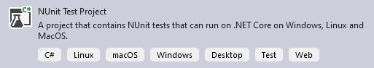

**Name** the project "HouseRentingSystem.Tests":

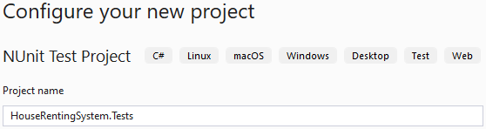

The **created project** looks like this:

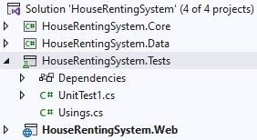

You can **delete** the UnitTest1.cs **file**, as we will create our test classes.

The default NUnit **packages** are **already installed** in the project. However, you should install some additional ones. For example, the **mocked database** will be an **in-memory database**, so we need the Microsoft.EntityFrameworkCore.InMemory **package**. We also need the AutoMapper.Extensions.Microsoft.DependencyInjection **package**, as we will create an AutoMapper **mock**. Be careful with **package versions**! The additional packages you need are these:

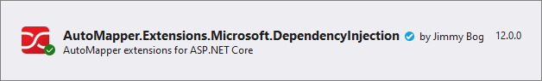 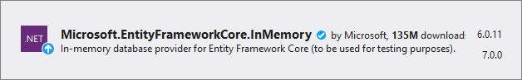

One more thing we should do is to make our **tests project dependent on the tested projects**. For now, we want to **test the data and service layer**, so the "HouseRentingSystem.Tests" **project** should **depend** on the "HouseRentingSystem.Core" and "**HouseRentingSystem.Data**" ones.

Now our project is ready, so we can start **adding different test classes**.

### Step 2: Modify the HouseRentingDbContext Class

The HouseRentingDbContext **class** is **responsible for our database**. However, in our tests, we want to use a **separate database**, which is **not our production one**. For this reason, we will **mock the** db context and **create an** **in-memory database for testing**.

To do this, however, we should first **modify our** HouseRentingDbContext **class**, so that we can **mock it correctly**. First, we should **modify the class constructor** – the **in-memory database we will create is non-relational**, so we **cannot migrate** it. We should only **make sure that it is created**, so the **constructor** should use a **different method**, depending on the database, like this:

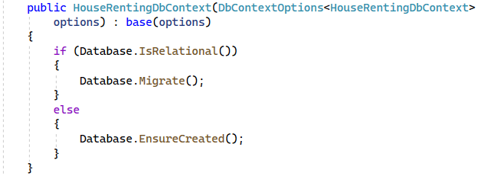

Next, we should **modify our database seed** – our **testing database should not be seeded**, as the production one, but will have **different data**. For this reason, **accept a** bool **parameter through the constructor**, which defines whether the **database should be seeded or not**. If it is false, **do not invoke the seed methods** in the OnModelCreating(…) **method**. Do it like this:



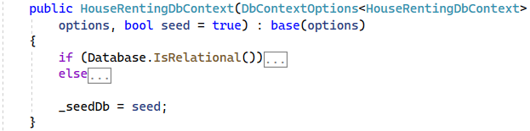

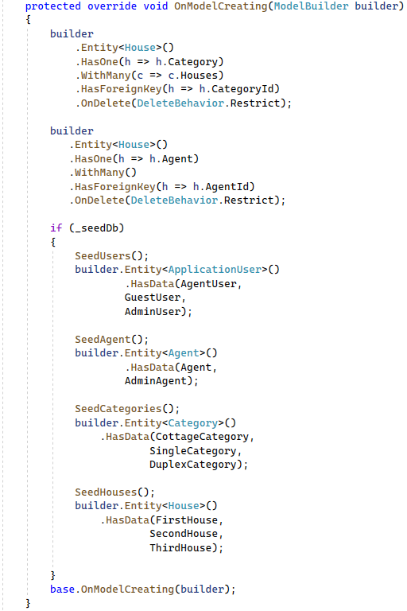

Now let's see how to **mock the database** for our tests.

### Step 3: Create a Database Mock

In this task, we will **create a mocked database**. The reason for this is that our **service classes need a** dbcontext, but we **cannot work with the production database**. However, it is important to **unit-test our business logic** and its **interaction with a database**. That's why we need to **create an artificial database for testing** purposes only.

Our **mocked database** will be an **in-memory database**, which will be **filled with data**, which tests need. To begin with, create a "Mocks" **folder** in the "HouseRentingSystem.Tests" **project**, where all our **mock classes** will be. In it, create the DatabaseMock **class**:

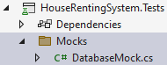 🡪 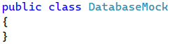

Make the class **static** and **add a single property** Instance. This property will have only a getter and will **return a** **new** HouseRentingDbContext **instance**, which will **create a not seeded**, **in-memory database** with a **unique name** every time:

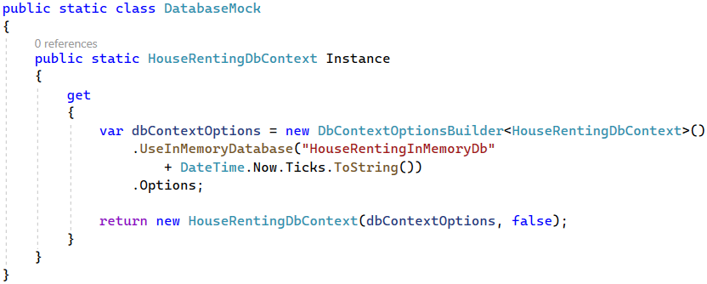

### Step 4: Create a Base Tests Class

Before we create our test classes and tests, let's **create a base tests class**, which should **instantiate the mocked** **database and seed some data in it**. Create the UnitTestsBase **class** in a "UnitTests" **folder** (for our unit test classes) in the "HouseRentingSystem.Tests" **project**:

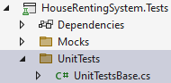

In the class, **use the mocked database instance** and **seed a renter**, **an agent**, **a rented house with a category** and a **non-rented house**. Create a SetUpBase() **method**, which has the [OneTimeSetUp] **attribute** and will be **invoked** **before all tests**:

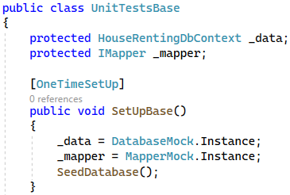

Then, **create properties for the seeded data** and **seed the database** in the SeedDatabase() **method**. Note that we are **not obliged to add values to all entity properties**, as our **in-memory database has no restrictions**:

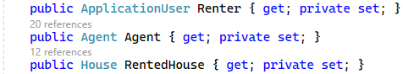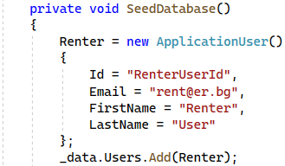  
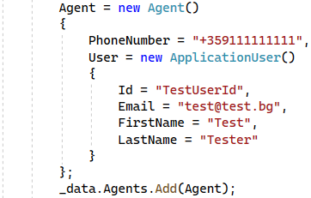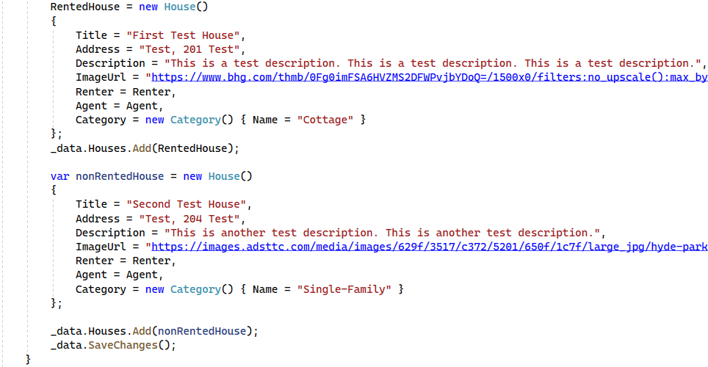

You can copy the **ImageUrl**s from here or choose your own:

|  |
| --- |
| <https://www.bhg.com/thmb/0Fg0imFSA6HVZMS2DFWPvjbYDoQ=/1500x0/filters:no_upscale():max_bytes(150000):strip_icc()/white-modern-house-curved-patio-archway-c0a4a3b3-aa51b24d14d0464ea15d36e05aa85ac9.jpg> |
| <https://images.adsttc.com/media/images/629f/3517/c372/5201/650f/1c7f/large_jpg/hyde-park-house-robeson-architects_1.jpg?1654601149> |

At the end, create the TearDownBase() **method**, which should have the [OneTimeTearDown] **attribute** and will be **executed after all tests**. It should only **dispose of the database** like this:

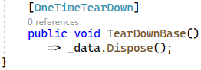

Now all **test classes** we create should **inherit the** UnitTestsBase **class** to **access the created database** with its **seeded data**.

### Step 5: Create AgentService Tests

The AgentService **unit tests** we will create will test the **service method functionalities**, which will interact with our **mocked database**.

First, **create the** AgentServiceTests **class**:

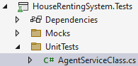

Then, use the [TestFixture] **attribute** to **mark the class as a test class**. Also, it should **inherit the base tests class** and **use its** db context to **instantiate the** AgentService **class**, which we want to test, in its SetUp() **method**:

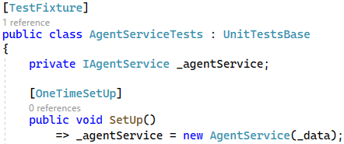

Now let's **examine the methods** of the AgentService **class**, which we should test. It is important to look at methods, because you can sometimes find out that you have **missed something or something is wrong**.

For example, in the AgentService class we can notice that the UserWithPhoneNumberExists() **method's** **name** is **not suitable** and meaningful enough, as it returns whether an **agent with the given phone number exists**. For this reason, let's **rename the method** to "AgentWithPhoneNumberExists":

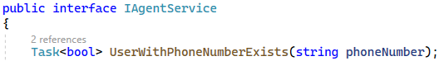

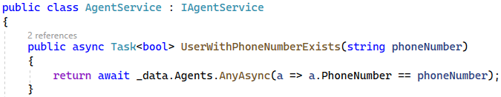

Another thing we can notice is that the UserHasRents(…) **method's place** **is not in the** AgentService **class**, as it is **connected to users**, not to agents. For this reason, let's **move the method** to the UserService **class** and use it where needed. Don't forget to **modify the** IAgentService **and** IUserService **interfaces**, as well. All **modifications** are shown below:

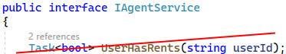

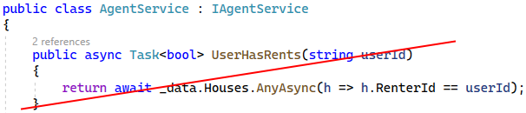

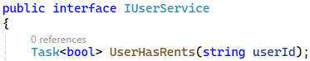

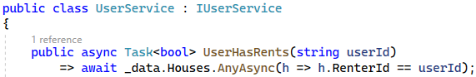

You should also **modify the** AgentController and its Become(…) **method** to use the above method:

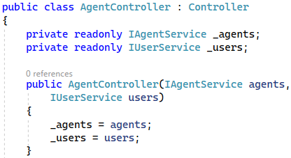

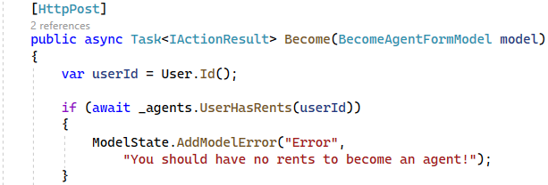

After we have **examined the** AgentService **class**, go back to the AgentServiceTests **test class** and let's **write** **test methods**. We have already **instantiated the service and** db context **classes**, so we have everything for our tests.

#### Test the GetAgentId(…) Method

Start with testing the GetAgentId(…) **service method**, which **returns the id of an agent with a given user id**, if it **exists**. Create a **testing method** with the Act-Arrange-Assert **pattern** and the [Test] **attribute** like this:

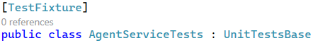 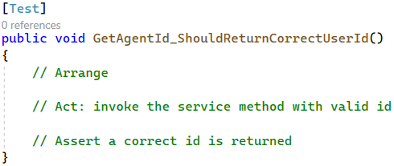

We already **have an** Agent **in our database**, which we will **use in for this test**. So, we should **directly invoke the** GetAgentId(…) **service method** and **get its returned value**. At the end, we should **assert that the returned user id** is the same as this in the UserId **property of the agent**. Write the test like this:

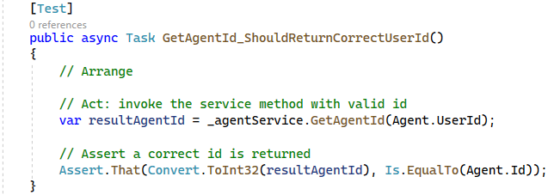

Note that in the Assert.AreEqual(Object expected, Object actual) **method** you should first place the **expected value**, then the **actual one**, so that you can have a **correct exception message** in case of a **wrong test result**.

Our test is ready. Now open the Test Explorer from [Test] 🡪 [Test Explorer] and **run the test** with the **arrow button**. It should be successful:

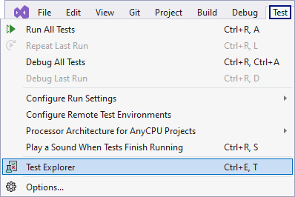 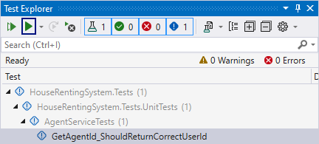

Note that if you have **any trouble with a test**, you can **add a breakpoint** and **debug it** by **right-clicking** on the test and **choosing** [Debug]:

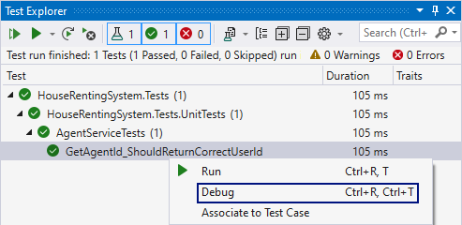

#### Test the ExistsById(…) Method

Our **next test** will be for the ExistsById(…) **service method**. In the test, we should **invoke the method** and make sure that it **returns** true **when we test it with a valid user id**. Do it like this:

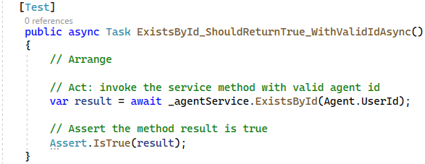

**Run all tests** with the **double arrow button** and make sure that they are **all** **sucessful**:

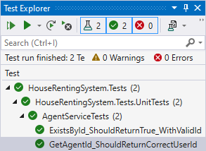

#### Test the UserWithPhoneNumberExists(…) Method

To test the UserWithPhoneNumberExists(…) **method** we should **invoke it** with an **already-used phone number** and make sure that it **returns** true, meaning that an agent with this phone number already exists (as we added it to our database). Write the test as shown below:

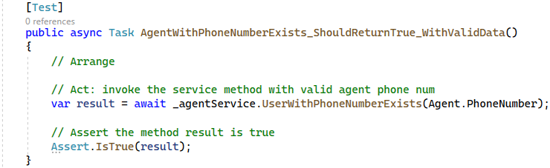

Run the test and make sure it is successful:

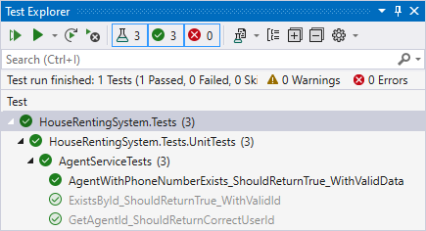

#### Test the Create(…) Method

The last and most difficult method from the AgentService **class** is the Create(…) **method** for **adding an agent** to the database. To **test** this method, we should first **get the number of agents** in the database **before the creation:**

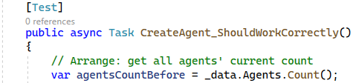

Then, **invoke the** Create(…) **method**. Note that it will **create the agent in the database**, no matter if there is an **agent with the given user id** already – the **method does not check** this. Do it like this:



Finally, **make the needed test assertions**. First, make sure that the **agents' count has increased by 1** with the addition of the **new** Agent:



Then, **use other service methods** (we assume they work correctly) to **get the newly-added agent** from the database. Then, make sure its **data is correct**:

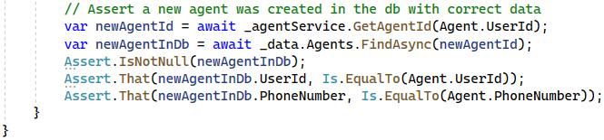

**Run all tests** for the AgentService **class** together:

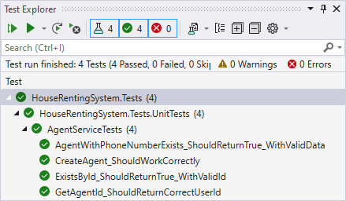

Continue with **writing test for other service classes** or, if you want, you can add some **more tests** for the AgentService **class** with **invalid data**.

### Step 6: Create StatisticsService Tests

Now let’s create **a test** for the only method of the StatiticsService **class** – the Total() **method**, which **returns the number of all houses and the number of all rented houses** in the database. **Examine the method** before you test it.

Now create the StatisticsServiceTests **class** in the "HouseRentingSystem.Tests" **project**. In it, add a SetUp() **method** which should **instantiate the service class**:

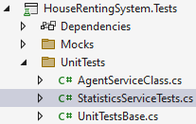

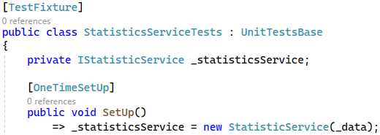

Now **write the test method**, which should **test the** Total() **service method**. First, **invoke the method**, then make sure that it **returns the correct houses and rents count**. The test should be the following:

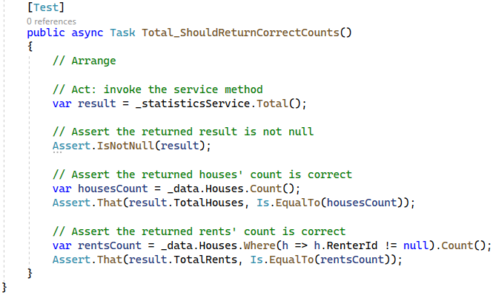

### Step 7: Create a Mapper Mock

The next service class we want to test is the RentService **class**. However, we should first **create a mocked** **mapper**, as the service class and its method depend on it.

For this reason, let's **create a** MapperMock **class** in the "Mocks" **folder** of the "HouseRentingSystem.Tests" **project**. It should have a **single property** Instance with a getter. It should **return a mapper**, which uses the **mappings from the** ServiceMappingProfile **class** in the "HouseRentingSystem.Services" **project**.

Create and write the class like this:

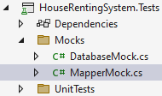 🡪

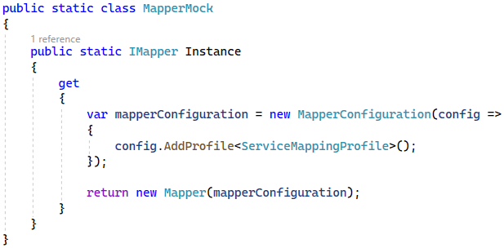

**Instantiate the mapper** in the UnitTestsBase **class (**if you haven't**)** to **use it in child classes** like this:



Now you can **inject the mapper** when **instantiating service classes**.

### Step 8: Create RentService Tests

In the RentServiceTests **class** we will **write tests for the** RentService **class**. **Examine the services class** and its **methods** for testing. Then, create the RentServiceTests **class** and write its SetUp() **method** to **instantiate the** **service class**. Do it as shown below:

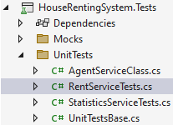 🡪

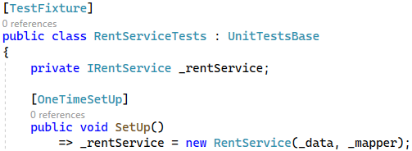

Test the All() **service method** by invoking it. The method should **return only the rented house** as a **service model** with **correct property values**. The test may look like this:

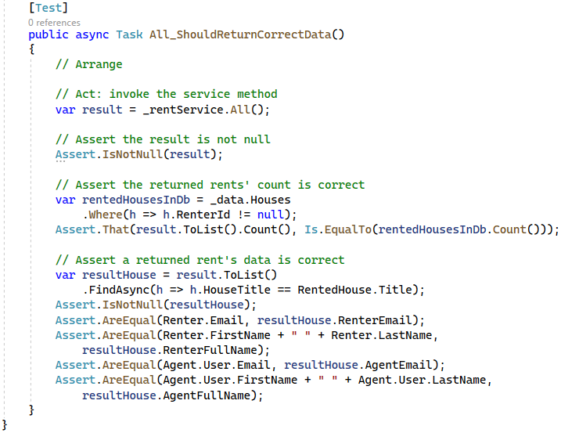

**Run all tests** together.

Note that our last test is successful because the **mocked mapper** we created is **working correctly**.

### Step 9: Create UserService Tests

Tests for the UserService should be created in the UserServiceTests **class**. It should **inherit the base tests** **class** and **instantiate the service class** in its SetUp() **method**:

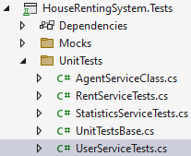 🡪

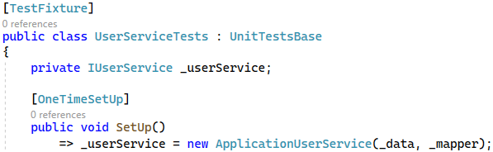

Next, **examine the methods** of the UserService **class** and **write tests** for each of them. Tests may be the following:

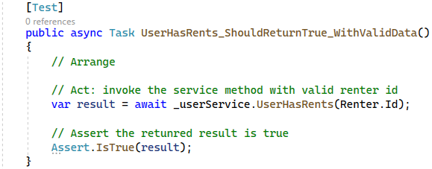

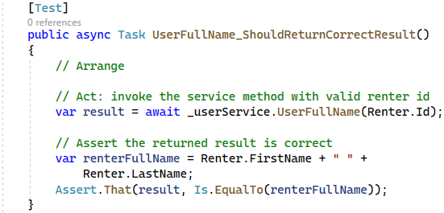

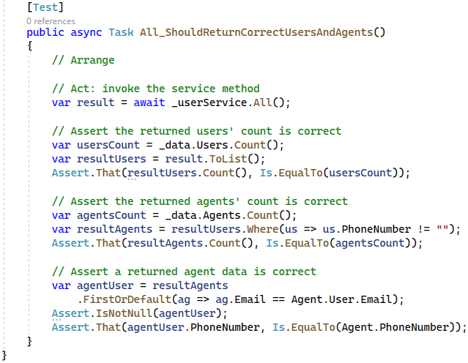

All tests should be **successful**.

### Step 10: Create HouseService Tests

**Tests** for the HouseService **class** will be in the HouseServiceTests **class**:

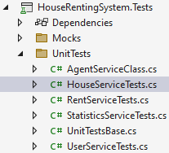

The **class's** SetUp() **method** should **instantiate the** UserService **and** HouseService **classes**, as shown below:

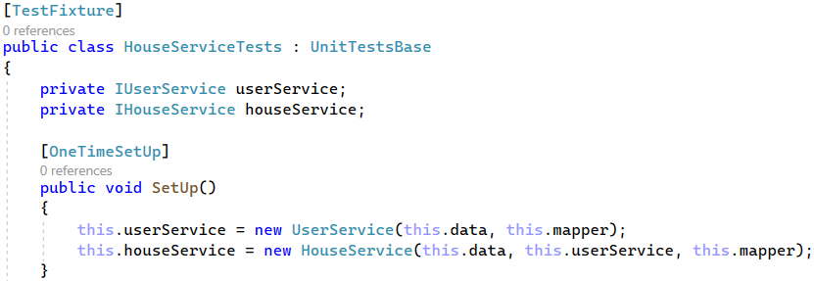

Now you should try to **write tests for all service methods by yourself**. Tests are **similar** to the ones we already created for other service classes. **Write all tests by yourself**. However, note that you should **add some new** House **records** to the **database** for **testing the** Edit()**,** Delete()**,** Rent() **and** Leave() **methods**, so that **tests do not depend on each** **other**. If you have any difficulties, **look at the code for the tests** below:

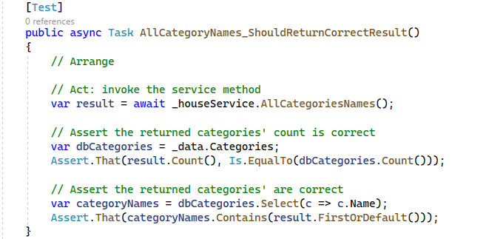

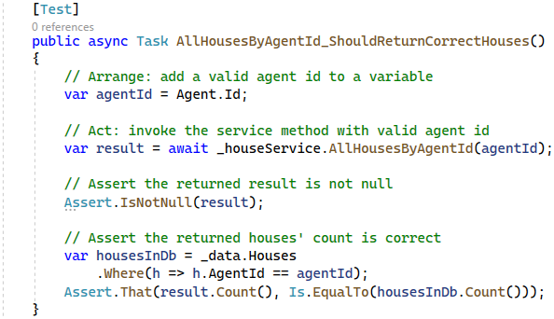

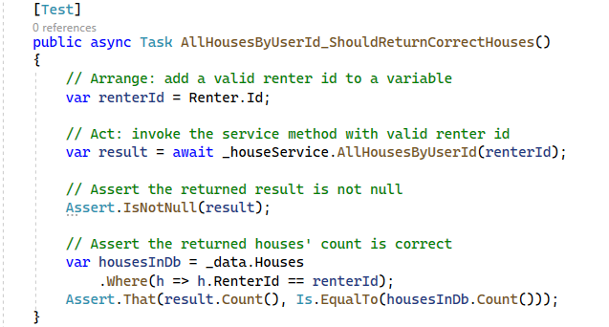

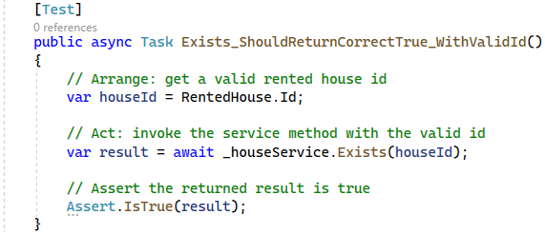

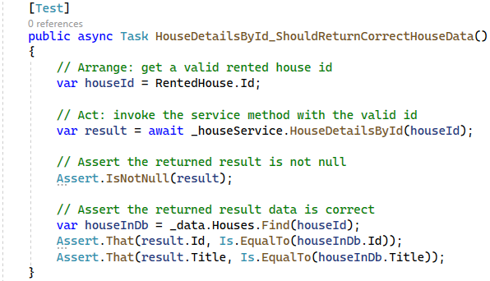

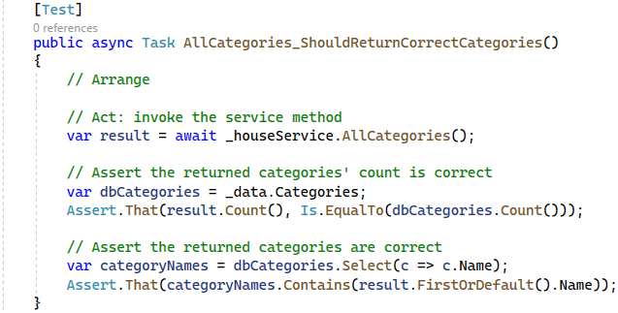

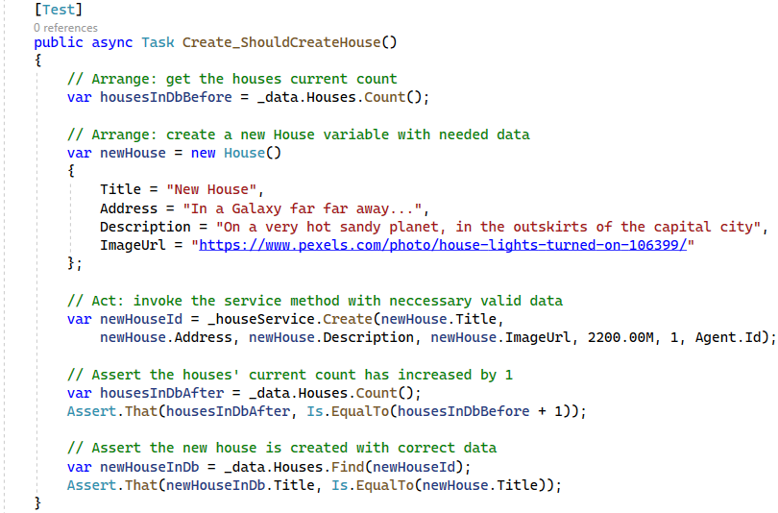

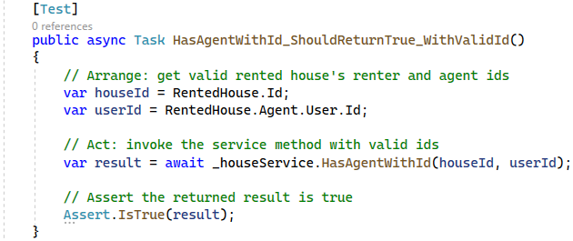

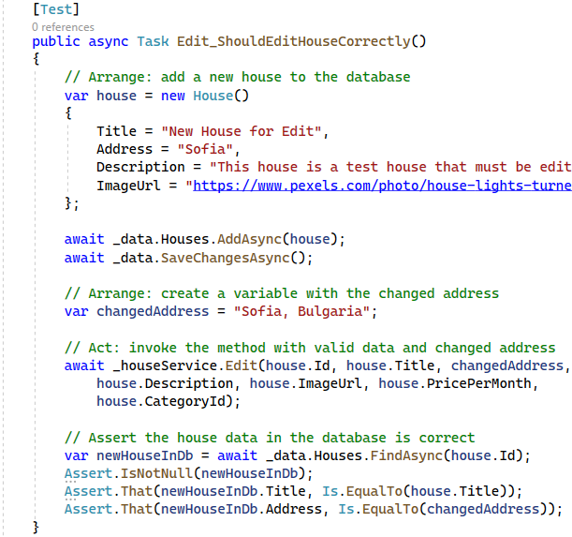

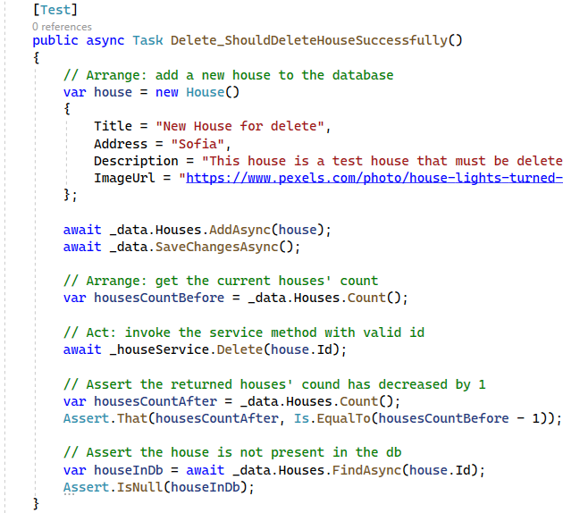

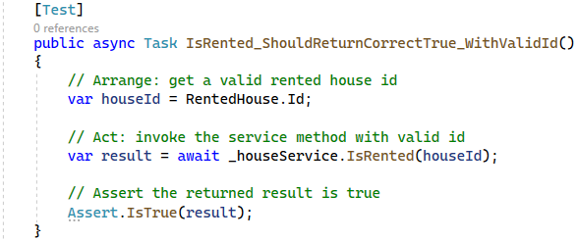

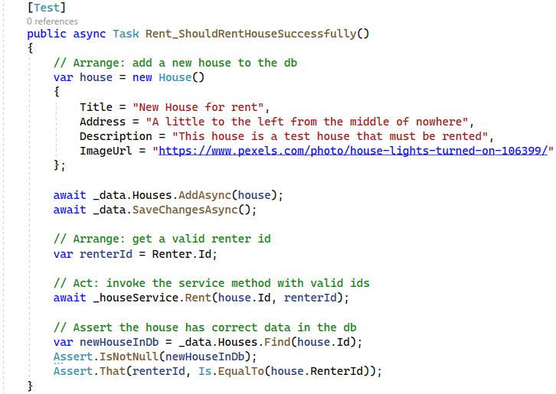

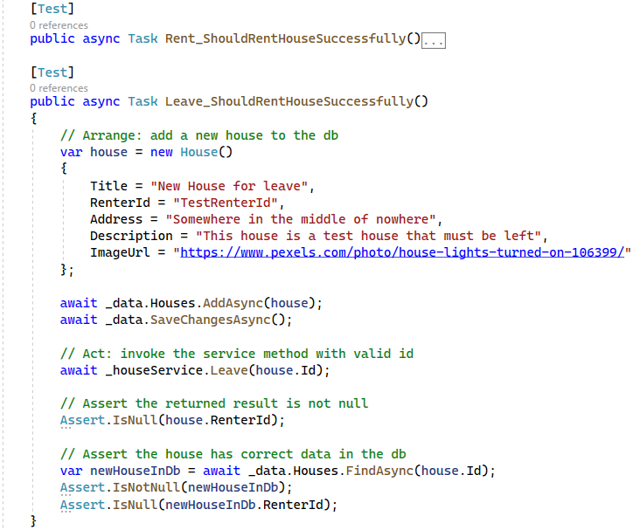

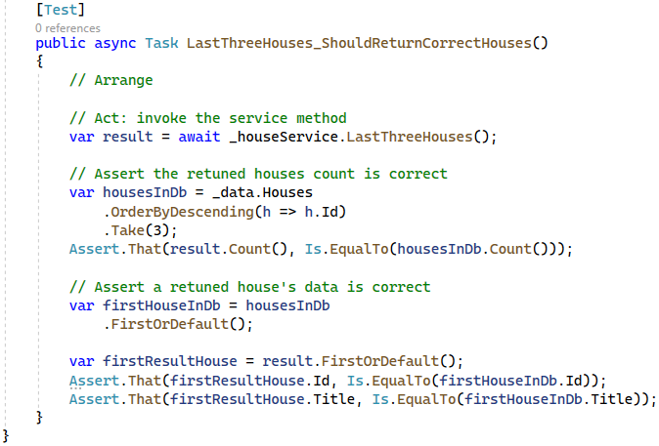

We have now **18 test method** for the HouseService **class**. **Run them all together** with other tests. They should all be **succesful**.

## Write Integration Tests

In this task, we will show you **examples of integration tests**. In our case, the **integration tests** should **test** **controllers' functionality**, as **controller methods combine service methods**, tested in unit tests. We will write only **two easy tests**.

First, create a new "IntegrationTests" **folder** in the "HouseRentingSystem.Tests" **project**, where we should keep our **integration test classes:**

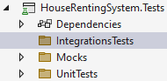

As we will **test the controllers** from the "HouseRentingSystem.Web" **project**, we should make "HouseRentingSystem.Tests" **depend** on it:

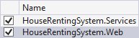

### Step 1: HomeController Test

The HomeController has **two methods** – Index() and Error(). In our case, we will **test only the** Error() **method**, because the Index()needs a **more complex mocking**.

Create the HomeControllerTests **class**, which should **instantiate the** HomeController in its SetUp() **method**. Pass a null **value**, instead of an IHouseService **instance** to the **controller constructor**, as we **don't use service** **methods** in the Error() **method**:

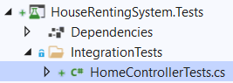 🡪

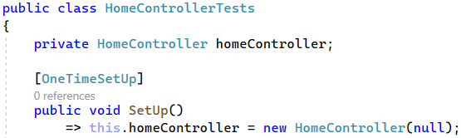

Now **create a test** for the Error() **method**, which should check **whether the method returns a view**. Write it like this:

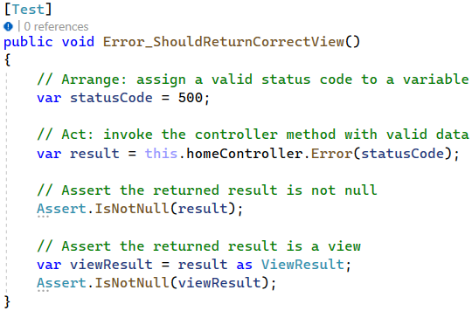

### Step 2: StatisticsApiController Test

Now we will **test the** GetStatistics() **method** of the StatisticsApiController **class**, as the controller **depends** only on the StatisticsService **class**.

The StatisticsService **class** will be **mocked**. However, it will be **different from the** DatabaseMock **and** MapperMock **mock classes**.

For the StatisticsService **class mock**, we will **need the** "Moq" NuGet **package**. **Install** it:



Now create the StatisticsServiceMock **class** in the "Mocks" **folder** of the "HouseRentingSystem.Tests" **project**. The **mock class** will have a **property with a** getter, which should **return the mocked service instance**. It should also **set hardcoded models**, which will be returned when a **service method is invoked**.

The StatisticsService **class** has a **single method to be mocked** and the **mock class** should look like this:

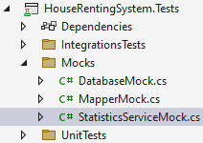 🡪

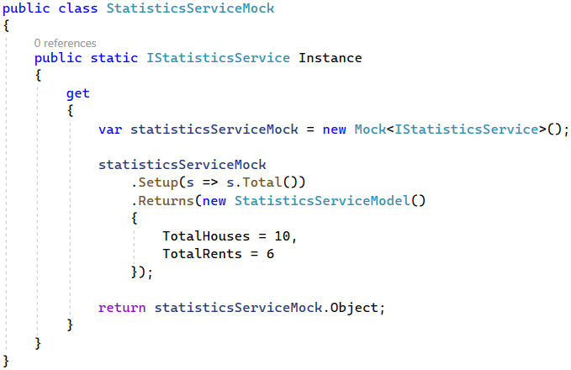

Now use the **service class mock** in StatisticsApiController **tests**. Create the StatisticsApiControllerTests **class** and **instantiate the controller** with the **mocked service**:

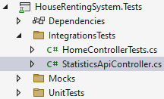 🡪

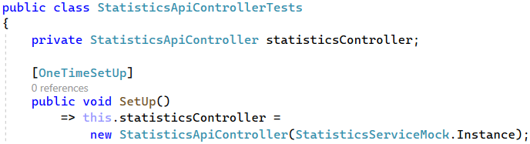

The **test** for the GetStatistics() **method** should check whether it **returns a correct result**. Write it like this:

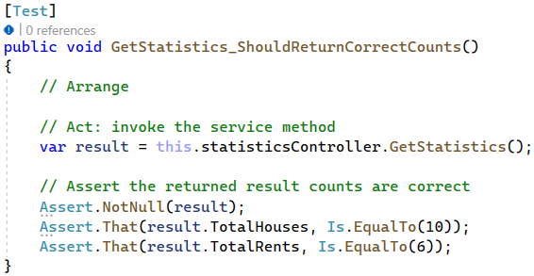

Now we have learnt how to **write both unit and integration tests**. However, you can **add more integration tests** and try to **test more complex controller methods**, if you want.

## Check Code Coverage

**Code coverage** is the **percentage of code** which is **covered by automated tests**. We want to check it to understand if the **tests we have are enough** to cover **most of our app functionalities**, if not all.

To **check the code coverage** in Visual Studio, we should either have VS Enterprise, or we should use the dotCover **tool** of JetBrains. Let's see how to **use the tool**, as VS Enterprise is not free.

### Step 1: Download and Install the dotCover Tool

First, **download** dotCover from the JetBrains's site or from the following **link**: <https://www.jetbrains.com/dotcover/>. You should just **click on the** [Download] **button** and on the **downloaded** .exe **file** to **open it**:

When you **open the file**, you should **choose** **to install** dotCover on your **current** VS **version**:

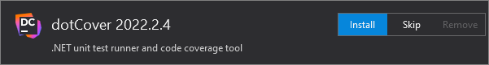

Check the option **[I have read and accept the license agreement]** and click on the **[Next]** button.

On the next window, you should just **click the** [Install] **button**. Note that you will **also install** ReSharper, as dotCover **needs** **it**:

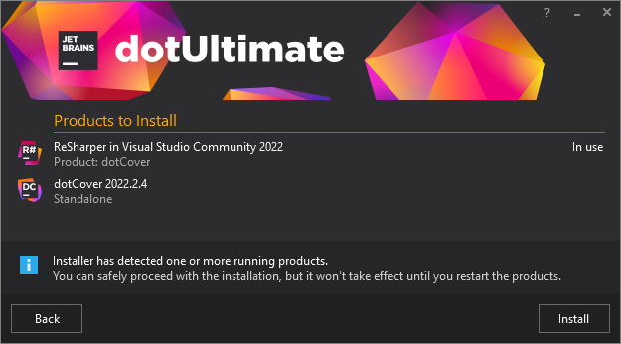

**Wait for the installation** to finish and **exit the window**. Now **close and open** Visual Studio again.

In VS, go to [Extensions] 🡪 [ReSharper] 🡪 [Start ReSharper].

If you **don't see the above buttons**, **wait** for VS to show them or **restart** it. If a **user agreement window** appears, **scroll down** and **click on** [I Accept] and [OK] **buttons** on the first two windows. On the **next window**, **click on** [Start trial] on dotCover and **proceed**:

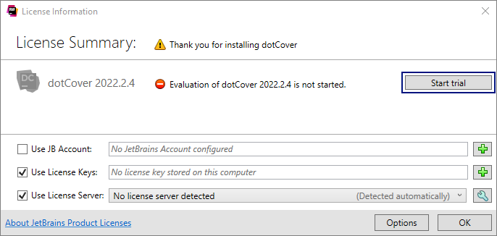

Then, **click on the** [Log in with JetBrains account] **button** and **follow the instructions** to **log in** or **create an** **account**:

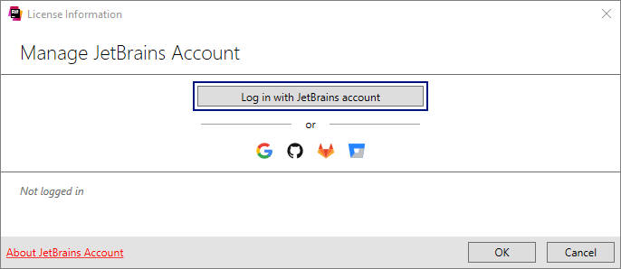

When done, the window should **display that you are logged-in**. Then, **click on** [Start trial of dotCover]:

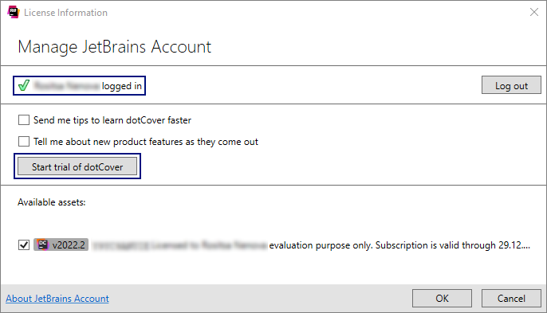

You **trial** should be **started successfully**:

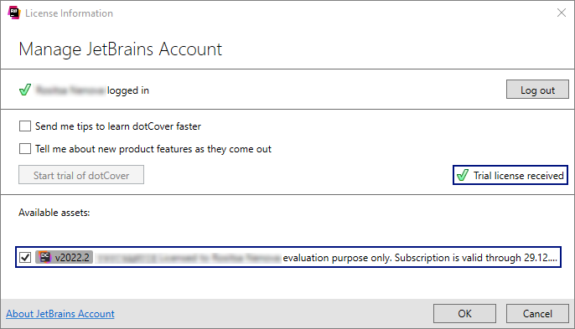

Finally, **click on the** [OK] **button** on this and on the next window.

### Step 2: Check the Code Coverage

Now you can go **back to** VisualStudio and **click on** [Extensions] 🡪 [ReSharper] 🡪 [Unit Tests] and choose [Cover All Tests from Solution]. This will **run all tests** on a new window:

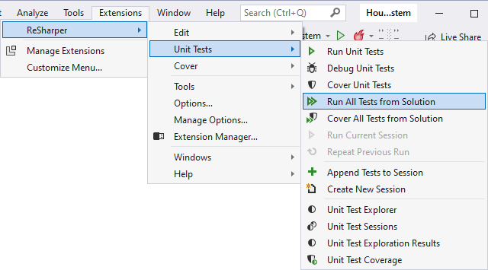

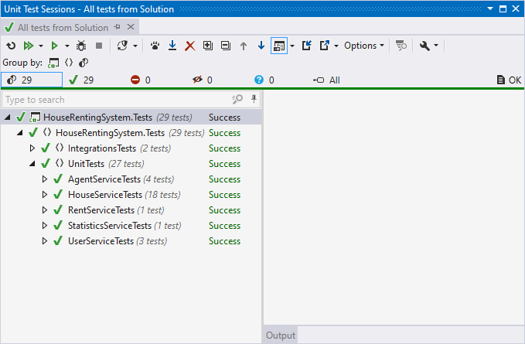

All tests should be **successful**. In order to see the **unit test coverage** **of tests**, click on **[Extensions] 🡪 [ReSharper] 🡪 [Unit Tests] 🡪 [Unit Tests Coverage]**:

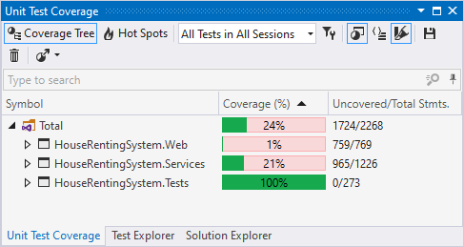

Look at the **coverage** of the "HouseRentingSystem.Services" **project** with our **services**, as it is the important one for us. You can see that the **coverage percentage** for the "Data" **folder classes** is small and it **decreases our** **overall percentage**.

However, our aim was **not to test the data layer** but mostly the **services**, so you can **exclude the** "Data" **folder test** **coverage** by **right-clicking** on "Data" 🡪 [Exclude from Coverage Results]:

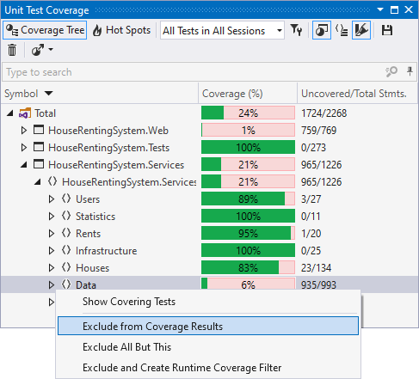

Now the **coverage** of the "HouseRentingSystem.Services" **project** is the one we should be looking for:

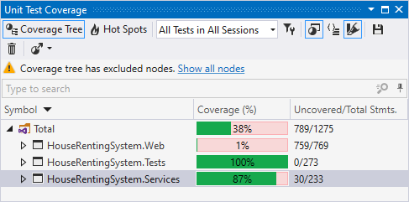

If you need to **write more tests** to **reach this percent**, you can examine more carefully which **service classes are** **tested less** than others and **write tests for them**:

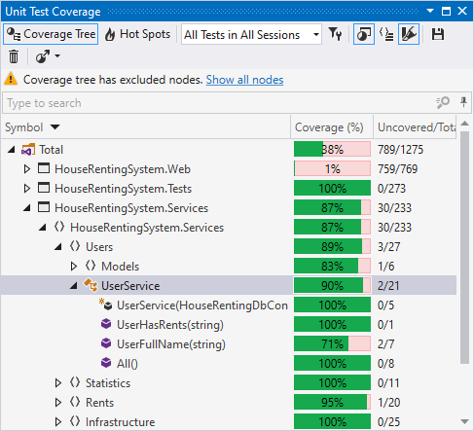

Make sure that you have **written enough tests** for your app. If you **cannot reach the required code coverage** with the **positive test cases** for each service method, you can **add some negative tests cases**.